232

Vintage Robotics

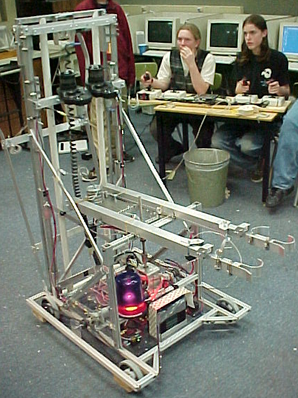
The Crusher
Team 232 - Gillmore Foundation; Gasser Foundation; Grainger; Kleiner, Perkins, Caufield & Byers; and Vintage High School

Ability Chart:
Goal Balancing | Ball Grabbing | Field Crossing | Bridge Tending | Other
1 Goal w/o robot | 1 Big Ball | Over Bridge | N/A | Pull Stretcher

Notes:
- 4-wheel drive base with drill motors.
- Globe motor powers “claw” that grabs onto 1 big ball.
- Fisher-Price motors operate lift that raises big ball to goal height.
- Van door motors power goal “grabber” that grabs onto one goal.

Comments:
_________________________________________________________________
_________________________________________________________________
_________________________________________________________________
_________________________________________________________________

